ARNOLD’S TEXAS BAR-B-Q

I attribute my success with Texas Bar-B-Q & Chili to working with my grand father and paying attention to my grandmothers Mexican cooking.

My early recollection of East Texas Style Bar-B-Q goes back to working with my grandfather at the ripe old age of 6 in 1955, delivering fresh cut green hickory wood that I had helped cut ,load, deliver & stack at East Texas Bar-B-Q which located in East Dallas on Hall Street just 1 block up the street from another of Dallas’s best BBQ establishments at the time, Papa Dads BAR-B-Q and across the street from the legendary Henderson’s Fried Chicken that had been frying up bird until 2000.

East Texas BAR-B-Q was a little bricked BBQ Joint about 1,200 sq ft., with thick clouds of hickory smoke & the irresistible aroma of BBQ beef cooking & circulating through-out the inside of the well seasoned small building. You were greeted by 2 old grey haired black gentlemen in their (70’s) wearing white baker’s hats, aprons & million dollar smiles, standing in front of an unventilated brick indoor pit.

The best part of this experience was watching them remove the fresh smoked brisket out of the well seasoned black brick pit with grease glazed metal smoking doors, which were right in front of you, it made you so hungry looking into the pit loaded with large golden brown hunks of beef and delicious looking reddish slabs of pork spare ribs and strings of small linked sausages hanging inside the pit, then they would trim, slice & serve your order to you right before your eyes, and onto a grey egg carton style food tray lined with butcher block paper with your meat on top of 2 slices of white bread topped off with a thin Tabasco type BBQ sauce then placed into a plastic Sunbeam Bread bag that steamed up as they twisted it closed. They didn’t use scales, they just knew from experience how much a pound of meat weighed. I can see it and dam near taste it like it was yesterday!

At the age of 14, converted the Family back yard grill into my first BAR-B-Q Pit and had begun to learn outdoor cooking techniques and the use of different chilies & spices my grandmother had used as long as I could remember and later perfected methods of cooking with fire-woods and in that process developed a natural feel for timing and temperatures necessary for cooking perfect barbecued meats. In addition, I was able to develop my own style of sauces, marinades & dynamite chili which I use to this day!

My childhood food experiences and memories of East Texas BAR-B-Q’S combination of the aroma of fresh green hickory, 50’s BBQ atmosphere, preparation & presentation proved to be my inspiration for my unique award winning Texas Style Bar-B-Q Catering company & National Touring Championship Arnold’s Texas
BAR-B-Q & CHILI Team in 1979 and the opening of Arnold’s Texas BAR-B-Q, Chili Depot, Dallas Texas in 1989 & today’s Dallas BBQ Catering Company.

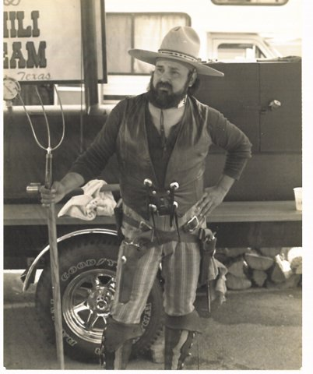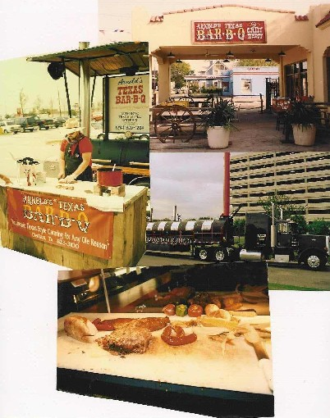
1984-85 BBQ GRAND CHAMPION
Arnold’s TEXAS BBQ &CHILI DEPOT &
SPECIAL EVENTS PRODUCTION 1989

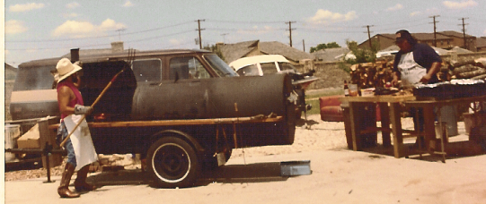
1st COMMERICAL BBQ CATERING JUNE 1979

